Course6-2

Sangwon Han

2018-12-18

# Overview

In the second portion of the project, we’re going to analyze the ToothGrowth data in the R datasets package.

# 1. Load the ToothGrowth data and explore data analyses

data(ToothGrowth)  
str(ToothGrowth)

## 'data.frame': 60 obs. of 3 variables:  
## $ len : num 4.2 11.5 7.3 5.8 6.4 10 11.2 11.2 5.2 7 ...  
## $ supp: Factor w/ 2 levels "OJ","VC": 2 2 2 2 2 2 2 2 2 2 ...  
## $ dose: num 0.5 0.5 0.5 0.5 0.5 0.5 0.5 0.5 0.5 0.5 ...

head(ToothGrowth)

## len supp dose  
## 1 4.2 VC 0.5  
## 2 11.5 VC 0.5  
## 3 7.3 VC 0.5  
## 4 5.8 VC 0.5  
## 5 6.4 VC 0.5  
## 6 10.0 VC 0.5

unique(ToothGrowth$dose)

## [1] 0.5 1.0 2.0

# 2. Provide a basic summary of the data.

summary(ToothGrowth)

## len supp dose   
## Min. : 4.20 OJ:30 Min. :0.500   
## 1st Qu.:13.07 VC:30 1st Qu.:0.500   
## Median :19.25 Median :1.000   
## Mean :18.81 Mean :1.167   
## 3rd Qu.:25.27 3rd Qu.:2.000   
## Max. :33.90 Max. :2.000

Plot box and whisker diagram

par(mfrow = c(1,2))  
plot(len ~ as.factor(dose), data = ToothGrowth, xlab = "Dose (mg/day)", ylab = "Tooth length")  
plot(len ~ supp, data = ToothGrowth, xlab = "Supplement", ylab = "Tooth length")

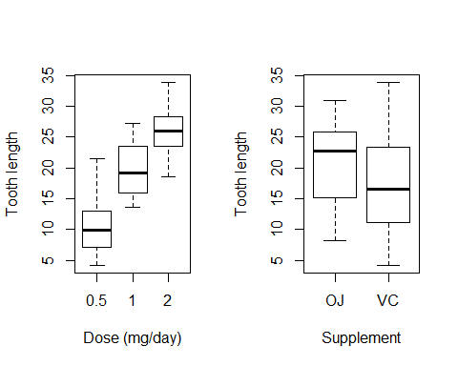

Plot box and whisker diagram according to supplement type subgroups

par(mfrow = c(1,2))  
plot(len[ToothGrowth$supp == "OJ"] ~ as.factor(dose[ToothGrowth$supp == "OJ"]), data = ToothGrowth, xlab = "Dose (mg/day)", ylab = "Tooth length", main = "OJ", ylim = c(5,35))  
plot(len[ToothGrowth$supp == "VC"] ~ as.factor(dose[ToothGrowth$supp == "OJ"]), data = ToothGrowth, xlab = "Dose (mg/day)", ylab = "Tooth length", main = "VC")

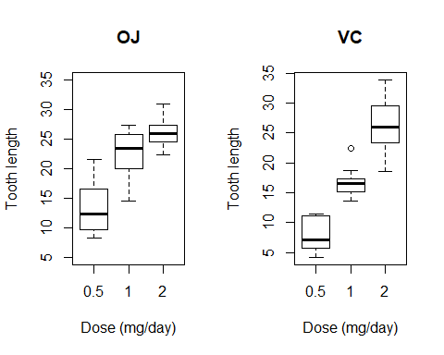

Plot box and whisker diagram according to dose subgroups

par(mfrow = c(1,3))  
plot(len[ToothGrowth$dose == 0.5] ~ supp[ToothGrowth$dose == 0.5], data = ToothGrowth, xlab = "Supplement", ylab = "Tooth length", main = "0.5 mg/day", ylim = c(5, 35))  
plot(len[ToothGrowth$dose == 1.0] ~ supp[ToothGrowth$dose == 1.0], data = ToothGrowth, xlab = "Supplement", ylab = "Tooth length", main = "1.0 mg/day", ylim = c(5, 35))  
plot(len[ToothGrowth$dose == 2.0] ~ supp[ToothGrowth$dose == 2.0], data = ToothGrowth, xlab = "Supplement", ylab = "Tooth length", main = "2.0 mg/day", ylim = c(5, 35))

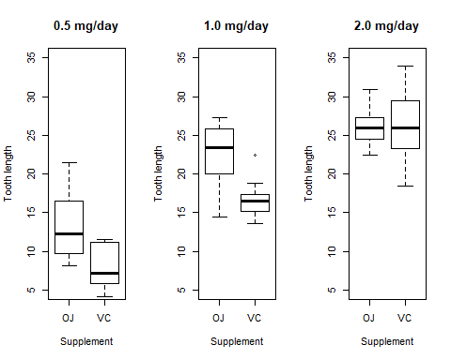

# 3. Hypothesis tests to compare tooth growth by supp and dose.

## 3-1. Supplement

See whether the test meets equal variance assumption

var.test(len~supp, data = ToothGrowth)

##   
## F test to compare two variances  
##   
## data: len by supp  
## F = 0.6386, num df = 29, denom df = 29, p-value = 0.2331  
## alternative hypothesis: true ratio of variances is not equal to 1  
## 95 percent confidence interval:  
## 0.3039488 1.3416857  
## sample estimates:  
## ratio of variances   
## 0.6385951

No significant difference in variance are shown.

Perform t.test function to compare two supplement groups

t.test(len~supp, data = ToothGrowth, paired = FALSE, var.equal = TRUE)

##   
## Two Sample t-test  
##   
## data: len by supp  
## t = 1.9153, df = 58, p-value = 0.06039  
## alternative hypothesis: true difference in means is not equal to 0  
## 95 percent confidence interval:  
## -0.1670064 7.5670064  
## sample estimates:  
## mean in group OJ mean in group VC   
## 20.66333 16.96333

## 3-2. Dose

See whether the test meets equal variance assumption

bartlett.test(len~as.factor(dose), data = ToothGrowth)

##   
## Bartlett test of homogeneity of variances  
##   
## data: len by as.factor(dose)  
## Bartlett's K-squared = 0.66547, df = 2, p-value = 0.717

No significant difference in variance are shown.

Perform aov function to compare three dose groups

ANOVA <- aov(len~as.factor(dose), data = ToothGrowth)  
summary(ANOVA)

## Df Sum Sq Mean Sq F value Pr(>F)   
## as.factor(dose) 2 2426 1213 67.42 9.53e-16 ***  
## Residuals 57 1026 18   
## ---  
## Signif. codes: 0 '***' 0.001 '**' 0.01 '*' 0.05 '.' 0.1 ' ' 1

Then, which group shows significant difference in tooth length?

TukeyHSD(ANOVA)

## Tukey multiple comparisons of means  
## 95% family-wise confidence level  
##   
## Fit: aov(formula = len ~ as.factor(dose), data = ToothGrowth)  
##   
## $`as.factor(dose)`  
## diff lwr upr p adj  
## 1-0.5 9.130 5.901805 12.358195 0.00e+00  
## 2-0.5 15.495 12.266805 18.723195 0.00e+00  
## 2-1 6.365 3.136805 9.593195 4.25e-05

# 4. conclusions

As shown above, we can conclude

1. Tooth length does not differ according to supplement delivery type.
2. Tooth length does differ among the three dose levels of vitamin C.